Wave Function Collapse

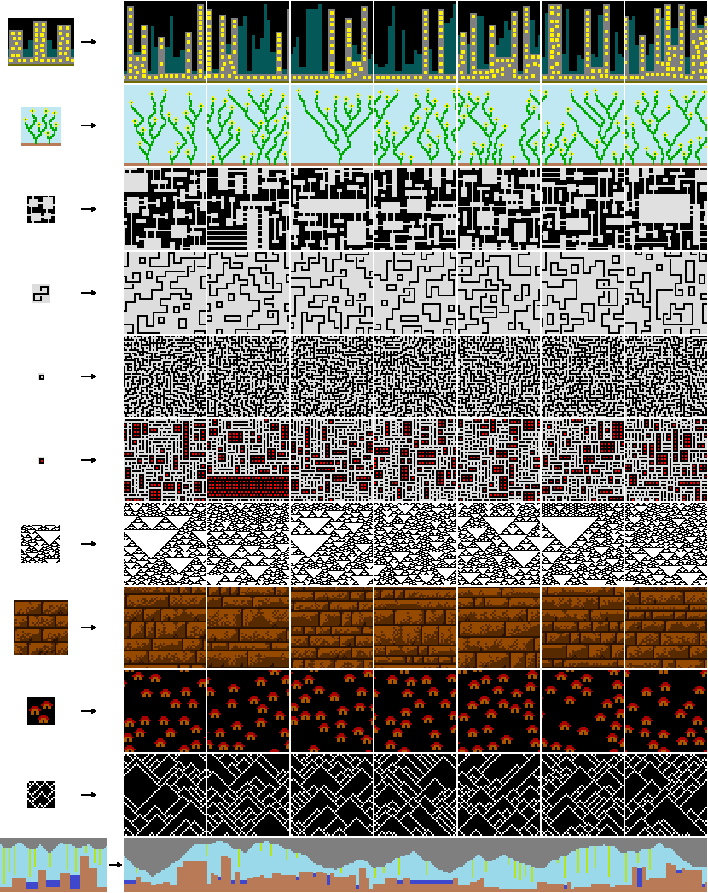

Figure <github.com/mxgmn/WaveFunctionCollapse>

Wave Function Collapse generates images using a grid where each cell can initially be any one of the patterns available – they’re in a superposition and have high *entropy*. A random cell is chosen to be *collapsed* into a single state. Each pattern can only be connected to certain other patterns in certain ways so, similar to playing sudoku, all the cells around our first cell have any now invalid patterns removed. For example, a beach tile may be able to connect to a sea tile or a grass tile but not a forest tile so if the collapsed cell is a beach then forest should be removed from the superposition surrounding cells are in. This is then repeated for the cells around them and so on, *propagating* out our collapse and reducing the entropy of multiple cells.

Figure Sudoku example from Martin Donald - [YouTube Link](https://www.youtube.com/watch?v=2SuvO4Gi7uY&t=250s)

To pick our next cell to collapse, the cell with the lowest entropy (fewest potential patterns) is found and collapsed. This then repeats until either a complete image is generated, or we reach a contradiction, and some cells have no valid patterns left after propagation.

# Creating the Canvas

The grid containing all our superposed cells, or the *wave,* can be represented with a 3D Boolean array where the first 2 dimensions represent x and y coordinates for cells in the final image and the 3rd represents each of the patterns available. For any cell true would mean that the corresponding pattern in another array is still allowed at this location while if it’s false, it’s not.

Later on, this could be expanded into a 3D model by adding an extra dimension to the arra

# Finding Connection Rules

## Simple Tiled Model

In the simple Tiled model, a cell only affects its direct neighbours like this example of a forest, grass, sea and beach.

Forest tiles can connect to itself and grass tiles

Grass can connect to itself, forests or beaches

Beaches can connect to itself, grass or sea

Sea can connect to itself or beaches

We also need to account for symmetry and rotation to make more interesting images

# Collapsing Cells

### Entropy

$H=\sum{\left(P\left(x\right)log⁡\left(\frac{1}{P(x)}\right)\right)}$

Where E is the entropy and P(x) is the probability of event x

In our case P(x) = weight / sum of weights so

$H=\sum{\left(\frac{w}{\sum{w}}log⁡\left(\frac{\sum{w}}{w}\right)\right)}$

Which can be simplified to

$H=\log\left(\sum{w}\right)- \frac{\sum{w}\log{w}}{\sum{w}}$

Which is a lot easier to calculate